Six Weeks Industrial training Project Report on
Crop Fertilization and Fertilizer Suggestion
Submitted in the partial fulfilment of the requirement for the award of degree of
Bachelor of Technology
in
Computer Science and Engineering
Batch
(2025-2026)


Submitted to: Dr. Shikha Magotra Submitted by: Harjot Singh
Reg no. 12300114

Department of Computer Science and Engineering
DAV University
Jalandhar-Punjab 144012

Acknowledgement

I express my gratitude to all those who helped us in various stages of the development of this project. would like to express my sincere gratitude indebtedness to DAV University for allowing me to undergo the summer training of 45 days at “ Phi- Brain regional office, Sector 64, Mohali” I am also thankful to all faculty members of Department of Computer Science and Engineering, for their true help, inspiration and for helping me for the preparation of the final report and presentation. Last but not least, I pay my sincere thanks and gratitude to all the Staff Members of Phi Brain Consultancy Services, 16 German Circle, Brampton Ontario CANADA L6X 5K4 at their regional office in Mohali, Sector 64, Mohali (Punjab) for their support and for making our training valuable and fruitful.

Declaration
I,hereby declare that the work which is being presented in this project/training titled “ Crop recommendation and fertilizer suggestion” by me, in partial fulfilment of the requirements for the award of Bachelor of Technology (B.Tech) Degree in “Computer Science and Engineering” is an authentic record of my own work carried out under the guidance of Mr. Manish Mishra (Senior Software Designer and Researcher). To the best of my knowledge, the matter embodied in this report has not been submitted to any other University/ Institute for the award of any degree or diploma.

Student Name: Harjot Singh
Signature: Harjot

Abstract
Agriculture is one of the most important sectors worldwide, providing food security, employment, and economic stability. However, farmers often face challenges such as choosing the right crop for their soil, improper use of fertilizers, soil degradation, and low productivity due to reliance on traditional farming methods. To address these issues, the Crop Recommendation and Fertilizer Suggestion System using Machine Learning has been developed as a smart, data-driven solution to assist farmers in making precise agricultural decisions.
The primary goal of this system is to recommend the most suitable crop based on soil nutrient levels—specifically Nitrogen (N), Phosphorus (P), and Potassium (K)—as well as other environmental factors like temperature, humidity, rainfall, and soil pH. In addition, the system provides suggestions for the optimal type and quantity of fertilizers required for the selected crop, promoting effective nutrient management and sustainable farming practices.
The project leverages machine learning techniques, specifically the Random Forest Classifier, which analyzes historical agricultural datasets to learn patterns between soil characteristics, environmental conditions, and crop performance. This predictive model ensures accurate recommendations by evaluating multiple factors simultaneously. For the user interface, Gradio has been used to create a simple and interactive web-based platform where farmers can input soil and environmental parameters and instantly receive crop and fertilizer guidance.
The system aims to enhance productivity, reduce crop losses, optimize fertilizer usage, and maintain soil health, thereby supporting sustainable and precision agriculture. Additionally, it provides farmers with a scientific approach to crop selection, reducing dependence on guesswork or traditional knowledge. The project has the potential for further expansion to include pest and disease prediction, irrigation guidance, crop yield estimation, and mobile application integration, making it a comprehensive smart farming solution.
In summary, this project bridges the gap between traditional farming practices and modern technology by combining data science, machine learning, and interactive web interfaces. It empowers farmers with actionable insights to make informed decisions, ultimately improving crop yield, reducing costs, and promoting environmentally sustainable agriculture

Sr.no | Table of Content
1 | Introduction
2 | Objectives of the Project
3 | Technologies and Libraries Used
4 | Coding and Implementation
5 | Real -World Applications
6 | Conclusion and Recommendation
7 | Appendices
8 | Bibliography

Chapter 1: Introduction
Agriculture is the backbone of many developing countries, including India. Farmers often make crop selection and fertilizer decisions based on experience or guesswork, which leads to:
- Low crop yield
- Soil degradation
- Wastage of fertilizers
- Financial loss
To solve these challenges, this project develops a Machine Learning based recommendation system that suggests:
The most suitable crop based on soil and weather conditions
The best fertilizer for the recommended crop
This system works as a Smart Agriculture Advisor to help farmers make scientific and data-driven decisions.

Chapter 2: Objectives of the Project
The primary goal of this project is to assist farmers and agricultural practitioners in making data-driven and scientific decisions regarding crop selection and fertilizer usage. The key objectives are as follows:
1. Crop Recommendation
- To analyse soil parameters (Nitrogen, Phosphorus, Potassium), pH, temperature, humidity, and rainfall.
- To recommend the most suitable crop for cultivation based on these factors.
- To help farmers choose crops that maximize yield and minimize losses.

2. Fertilizer Suggestion
- To provide accurate fertilizer recommendations for the selected crop.
- To ensure proper nutrient management, preventing overuse or misuse of fertilizers.
- To improve soil health and crop productivity through targeted fertilization.

3. Data-Driven Decision Making
- To use Machine Learning techniques, such as Random Forest, to analyze historical crop and soil data.
- To assist farmers in making scientific and precise farming decisions, rather than relying solely on traditional experience or guesswork.

4. User-Friendly Interface
- To develop a simple web-based interface (using Gradio) where farmers can enter soil and environmental parameters.
- To provide instant crop and fertilizer recommendations without requiring technical expertise.

5. Promote Sustainable Agriculture
- To optimize the use of resources such as water and fertilizers.
- To maintain soil fertility and promote environmentally friendly farming practices.To support precision farming techniques that lead to higher productivity and lower environmental impact.

6. Expandability and Future Scope
- To provide a system that can be extended in the future to include pest and disease prediction, crop yield estimation, and irrigation recommendations.
- To act as a foundation for smart farming solutions and integration into mobile or web agricultural advisory platforms

Chapter 3: Technologies and Libraries Used
The Crop Recommendation and Fertilizer Suggestion System is built using modern technologies and Python libraries that enable efficient data processing, machine learning predictions, and interactive user interfaces. The choice of these technologies ensures the system is accurate, scalable, and easy to use.

1. Python
- Python is a versatile, high-level programming language widely used in data science, machine learning, and web applications.
- Its simplicity and readability make it ideal for developing projects where data analysis and machine learning are required.
- Python also has a rich ecosystem of libraries, which allows for fast development and integration of different functionalities, from data preprocessing to web deployment.

2. Pandas
- Pandas is a powerful library for data manipulation and analysis.
- It allows structured handling of datasets, including importing data from various sources like CSV files, cleaning missing or inconsistent data, transforming values, and performing statistical analysis.
- In this project, Pandas is used to process soil and crop datasets, categorize features, and prepare data for machine learning modeling.

3. Scikit-learn
- Scikit-learn is a leading Python library for machine learning, providing tools for classification, regression, clustering, and model evaluation.
- It allows the creation of predictive models that can learn patterns from historical data and make accurate decisions on new data.
- In this project, Scikit-learn is used to implement the Random Forest Classifier, which predicts the best crop for given soil and environmental conditions.

4. Random Forest Algorithm
- Random Forest is an ensemble learning algorithm used for classification and regression.
- It builds multiple decision trees and merges their results to improve prediction accuracy and reduce the risk of overfitting.
- For this project, Random Forest analyzes multiple soil parameters, environmental conditions, and historical crop outcomes to suggest the most suitable crop.
5. Gradio
- Gradio is a Python library for building simple and interactive web interfaces for machine learning models.
- It enables non-technical users, such as farmers, to input soil and climate data and receive instant recommendations without writing any code.
- Gradio handles the user interface and output display, making the system accessible and user-friendly.
6. NumPy
- NumPy is a Python library for numerical computing and array manipulation.
- It supports large-scale mathematical operations and efficient handling of numerical data, which is critical for machine learning models.
- In this project, NumPy is used behind the scenes to manage input features and perform calculations required by the predictive model

Chapter 4 : Coding and Implementation

!pip install -q gradio pandas scikit-learn

import pandas as pd
import gradio as gr
from sklearn.model_selection import train_test_split
from sklearn.ensemble import RandomForestClassifier

# 📌 Load Dataset (WORKING URL)

url = "https://raw.githubusercontent.com/arzzahid66/Optimizing_Agricultural_Production/master/Crop_recommendation.csv"
df = pd.read_csv(url)

print("Dataset Loaded Successfully ✅")
print(df.head())

# 📌 Split Data

X = df[['N','P','K','temperature','humidity','ph','rainfall']]
y = df['label']

X_train, X_test, y_train, y_test = train_test_split(
X, y, test_size=0.2, random_state=42
)

# 📌 Train Model

model = RandomForestClassifier(n_estimators=200, random_state=42)
model.fit(X_train, y_train)

print("Model Trained Successfully 🌾")

# 📌 Fertilizer Suggestion Logic

fertilizer_data = {
"rice": "Urea, DAP, Potash — use nitrogen-rich fertilizer ",
"wheat": "NPK 2:1:1 + Good yield obtained from urea",
"maize": "NPK 3:2:1 and organic compost/manure.",
"sugarcane": "Ammonium sulphate + potash, More water is also needed",
"cotton": "Phosphorus rich fertilizer + organic manure.",
"banana": "High Potassium (K) — MOP + compost.",
"apple": "Calcium nitrate + organic ferstilier.",
"coffee": "NPK 15:15:15 + regular compost."
}

def fertilizer_suggestion(crop):
crop = crop.lower()
return fertilizer_data.get(
crop,
"General advice: NPK balanced fertilizer + use organic compost "
)

#
# 📌 Prediction Function

def recommend_crop(N, P, K, temperature, humidity, ph, rainfall):

# Input ko model ke format me daalna
user_input = [[N, P, K, temperature, humidity, ph, rainfall]]

predicted_crop = model.predict(user_input)[0]
fertilizer = fertilizer_suggestion(predicted_crop)

output = f"""
🌾 *Recommended Crop:* {predicted_crop.capitalize()}

🧪 *Fertilizer Suggestion:*
{fertilizer}

📌 *Your Soil Values:*
- Nitrogen (N): {N}
- Phosphorus (P): {P}
- Potassium (K): {K}
- Temperature: {temperature} °C
- Humidity: {humidity} %
- Soil pH: {ph}
- Rainfall: {rainfall} mm
"""
return output

# 💻 GRADIO UI

interface = gr.Interface(
fn=recommend_crop,
inputs=[
gr.Number(label="N (Nitrogen level)"),
gr.Number(label="P (Phosphorus level)"),
gr.Number(label="K (Potassium level)"),
gr.Number(label="Temperature (°C)"),
gr.Number(label="Humidity (%)"),
gr.Number(label="Soil pH"),
gr.Number(label="Rainfall (mm)"),
],
outputs="markdown",
title="🌱 Crop Recommendation + Fertilizer Suggestion",
description="Enter soil values to get the best crop recommendation and fertilizer advice."
)

# Colab me web app kholne ke liye
interface.launch(share=True, debug=True)

Figures :

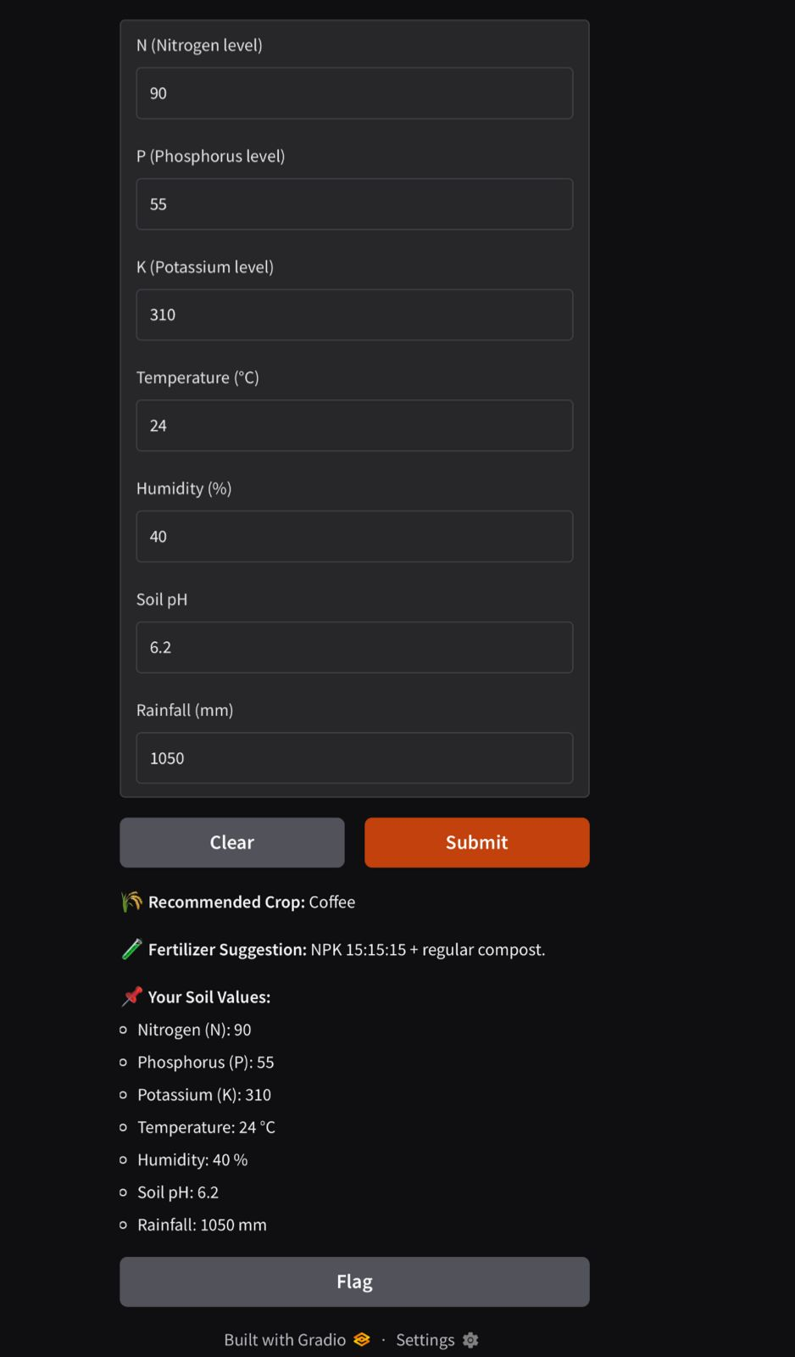
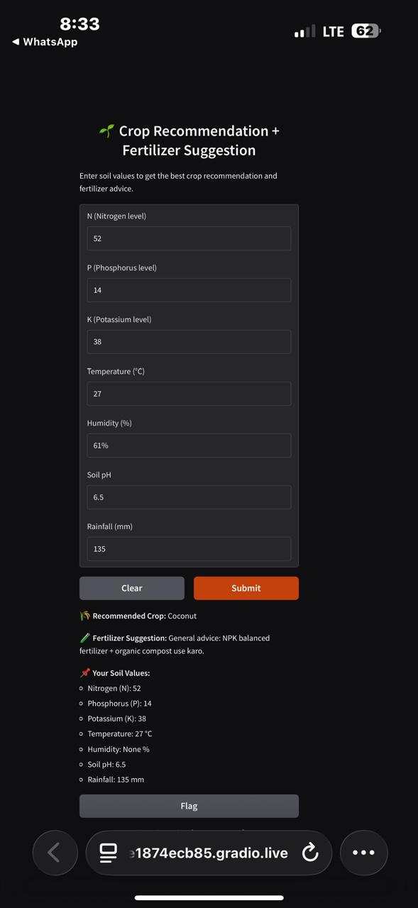

Chapter 5. Real -World Applications:
The Crop Recommendation and Fertilizer Suggestion System is designed to bring data-driven intelligence to agriculture, helping farmers make informed decisions about crop selection and fertilizer management. Its applications in real life are broad and impactful:

1. Precision Agriculture
- Helps farmers select crops that are best suited for their soil and climate conditions.
- Ensures optimal use of land resources by reducing trial-and-error crop selection.
- Supports site-specific farming, where decisions are tailored to the unique conditions of each farm plot.

2. Fertilizer Management
- Suggests the right type and amount of fertilizer for each crop based on soil nutrients.
- Reduces the overuse or underuse of chemical fertilizers, promoting cost savings and sustainable farming practices.
- Prevents soil degradation and environmental pollution caused by excessive fertilizer application.
3. Crop Yield Improvement
- By recommending the most suitable crop and proper nutrient management, the system helps farmers maximize productivity.
- Improves the quality and quantity of produce, ensuring better market value and economic return.
4. Risk Reduction
- Reduces the risk of crop failure due to inappropriate crop selection or nutrient deficiency.
- Helps farmers adapt to climate and soil constraints, thereby improving food security and income stability.

5. Decision Support System for Farmers
- Acts as a digital advisory platform for farmers, especially those with limited access to agricultural experts.
- Provides instant recommendations based on real-time input, eliminating guesswork in farming practices.

6. Educational Tool
- Can be used by agricultural students and researchers to understand the relationship between soil health, climate, and crop suitability.
- Helps train new farmers in modern, data-driven agriculture practices.

7. Government and NGO Initiatives
- Can assist government agriculture departments and NGOs in planning crop allocation, subsidy distribution, and agricultural extension programs.
- Enables large-scale soil and crop analysis to support policy-making and sustainable farming initiatives.

8. Integration with Smart Farming Technologies
- Can be combined with IoT-based sensors for real-time soil monitoring.
- Works alongside automated irrigation systems, drone-based monitoring, and mobile apps, creating a fully integrated smart farming ecosystem

Chapter 6: Conclusion and Recommendation
The Crop Recommendation and Fertilizer Suggestion System developed in this project successfully uses machine learning to support smarter agricultural decision-making. By training a Random Forest classifier on soil nutrients (N, P, K), environmental parameters (temperature, humidity, rainfall), and pH level, the system accurately predicts the most suitable crop to grow under given conditions. The integration of a fertilizer suggestion module enhances the usefulness of the model by providing farmers with practical guidance on improving soil quality and crop yield. The interactive Gradio interface makes the system easy to use, accessible online, and convenient for farmers, students, and agricultural planners. Overall, this project demonstrates how data-driven models can improve productivity, reduce risks, and support sustainable farming practices.

Recommendation:

Improve Fertilizer Module:
- Currently, fertilizer suggestions are rule-based. It can be enhanced with real nutrient-gap calculations for more accurate recommendations.
Add More Data:
- Include additional datasets from different regions to improve model generalization and handle diverse soil and climate conditions.

Deploy as Mobile/Web App:
- Converting the Gradio interface into a mobile or web application can make the system more accessible for real farmers.
Add Real-Time Weather API Integration:
- Fetching live temperature, rainfall, and humidity data will make predictions more accurate and context-aware.
Add Real-Time Weather API Integration:
- Fetching live temperature, rainfall, and humidity data will make predictions more accurate and context-aware.
Include Crop Yield Prediction:
- Adding a yield estimation module can further help farmers in planning crop cycles and estimating profit.
Use Explainable AI Techniques:
- Methods like SHAP values can explain why the model selected a specific crop, increasing trust and transparency.

Appendices
The project uses a publicly available Crop Recommendation Dataset containing soil and
soil and environmental parameters for different crops.

Sr no. | Column Name | Description
1 | N | Nitrogen content in soil (kg/ha)
2 | P | Phosphorus content in soil (kg/ha)
3 | K | Potassium content in soil (kg/ha)
4 | Temperature | Average temperature (°C)
5 | Humidity | Average humidity (%)
6 | ph | Soil pH value
7 | Rainfall | Rainfall (mm)
8 | label | Crop type (target variable)

Source: GitHub Crop Recommendation Dataset

Appendix B:
Python Libraries Used
- Pandas: Data manipulation and preprocessing.
- NumPy: Numerical computations.
- Scikit-learn: Machine learning model (Random Forest Classifier).
- Gradio: Web-based interactive user interface.

Appendix C:
Key Functions in the Code

- Data Preprocessing
- Handling missing values, normalizing data, splitting dataset into training and testing sets.
- Model Training
- Random Forest Classifier to predict suitable crop.
- Fertilizer Suggestion Function
- Maps crops to recommended fertilizers based on soil requirements.
- Prediction Function
- Accepts user input for soil and environmental parameters, predicts crop, and suggests fertilizer.
- User Interface
- Gradio-based UI for farmers to input values and get instant recommendations.

Appendix D:
Screenshots of User Interface
- Input Form: Farmers enter soil nutrient values, temperature, humidity, pH, and rainfall.
- Output: Recommended crop with fertilizer suggestions and soil details displayed in an easy-to-read format.
- (Include actual screenshots from your Gradio app if available.)

Appendix E:
Sample Output
- Recommended Crop: Wheat
- Fertilizer Suggestion: NPK 2:1:1 + Good yield obtained from urea
- Your Soil Values:
  - Nitrogen (N): 90
  - Phosphorus (P): 42
  - Potassium (K): 43
  - Temperature: 22 °C
  - Humidity: 70 %
  - Soil pH: 6.5
  - Rainfall: 120 mm
Appendix F:
Future Enhancements
- Integration with IoT sensors for real-time data.
- Mobile application for offline and remote access.
- Pest and disease prediction module.
- Yield estimation and market price forecasting

Bibliography
Datasets
Crop recommendation dataset: Ar Z. Zahid, “Crop Recommendation Dataset,” GitHub repository, https://github.com/arzzahid66/Optimizing_Agricultural_Production, 2023.
Python Libraries and Documentation
Pandas documentation: McKinney, Wes. Python for Data Analysis: Data Wrangling with Pandas, NumPy, and IPython, O’Reilly Media, 2017.
NumPy documentation: Harris, C.R. et al., Array programming with NumPy, Nature, 585, pp. 357–362, 2020.
Scikit-learn documentation: Pedregosa, F. et al., Scikit-learn: Machine Learning in Python, Journal of Machine Learning Research, 12, pp. 2825–2830, 2011.
Gradio documentation: Abid, A. et al., Gradio: Hassle-Free Sharing and Demo of Machine Learning Models in Python, arXiv preprint arXiv:2004.14140, 2020.

Machine Learning Concepts
Breiman, L., Random Forests, Machine Learning Journal, vol. 45, pp. 5–32, 2001.
Good fellow, I., Bengio, Y., Courville, A., Deep Learning, MIT Press, 2016.
Agriculture and Fertilizer Management
FAO (Food and Agriculture Organization), Fertilizer Use by Crop, FAO Corporate Document Repository, 2016. http://www.fao.org/3/x8618e/x8618e00.htm
Brady, N.C., Weil, R.R., The Nature and Properties of Soils, 15th Edition, Pearson, 2016.
Kumar, A. et al., Precision Agriculture: A Guide for Crop Fertilizer Management, International Journal of Agricultural Science, 2020.

Web Resources
Kaggle Datasets: https://www.kaggle.com/datasets
GeeksforGeeks Python ML tutorials: https://www.geeksforgeeks.org/machine-learning/
Medium articles on Crop Recommendation System using Python: https://medium.com

